
Company Profile
ECDARL TECHNOLOGIES LIMITED

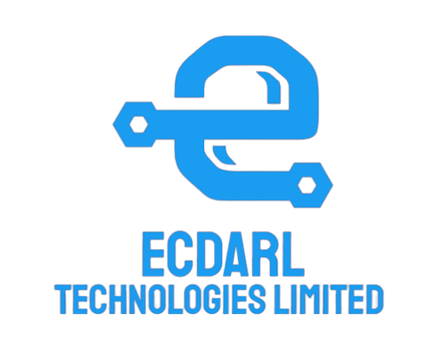


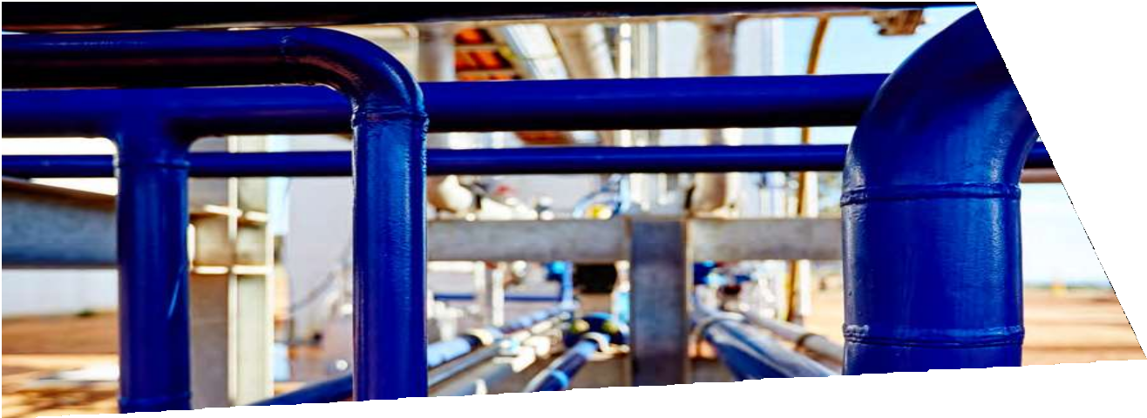



Mission Statement
To design, build and deliver flexible, integrated, best-in-class and cost effective engineering solutions.

Vision Statement
To be recognized as the expert in engineering services with top-notch Customer Service.

Our Commitment
As the oil and gas industry evolves we continue to partner with our clients, collaboratively developing solutions that are safe, sustainable and competitive.

Over the years successful project delivery has continued to be at the core of the business, allowing ECDARL to successfully move with the market – and our clients. The ECDARL team has successfully maintained long term client relationships.
A culture of collaboration plays a great part. Working closely with our clients we have been able to leverage our Operator’s mindset to develop innovative practices that deliver against safety, sustainability, expenditure, productivity and integrity measures.
Ecdarl is committed to expanding our business to deliver fully integrated services and projects that add value for our clients, our people and the communities in which we work.

ECDARL Technologies Limited is an incorporated organization, that provides the following technical support services to the oil and gas, power and manufacturing industries.

- METERING AND CALIBRATION
- PROCESS AUTOMATION & SCADA
- PIPELINE SERVICES
- PROCUREMENT
- CCTV & ACCESS CONTROL
- FIRE ALARM SERVICES
- NON-DESTRUCTIVE TESTING (NDT)

We have the experience and skills to turn objectives into reality, through technology innovation. As contractor we are ready to execute small as well as bigger scope of works for our customers at first class standard and quality.

We render services to all industries in which quality management services are required both within and outside the country.

Our core team is made up of engineers with different backgrounds and experience including Mechanical, Chemical, Electrical/Electronics and instrumentation. Supporting this core group of engineers are Technicians, Consultants, Auditors and
Lead Auditors with relevant experience profile capable of providing solutions to industrial problems. Another group of specialist in NDT.

WHO WE ARE
ECDARL Technologies Limited is an engineering and technology company. Proudly Nigerian owned and operated, ECDARL continues to provide a complete, value for money turnkey engineering service for all customers in every industry.
As an indigenous company we are established to offer world class services to oil and gas sector. Our core competency areas cover drilling/production equipment maintenance, engineering, procurement, construction, project management and technology support. Our operations are in compliance with local and international best work practices and hinged on safety, asset reliability, innovation, proficient and committed work force.
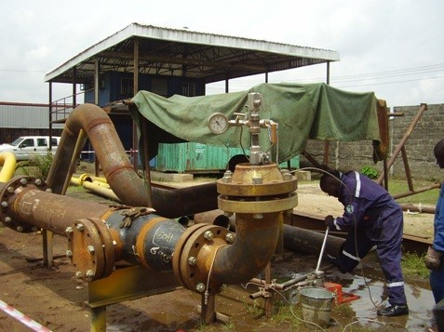
"Whatever the Customer wants or expects - that's what we deliver"
We have the experience and skills to turn objectives into reality, through technology innovation. As contractor we are ready to execute small as well as bigger scope of works for our customers at first class standard and quality.
“A solid foundation in operations and
maintenance promises quality solutions aligned with cost
We believe in approaching safety proactively from every angle to create a culture of zero harm. 360 DEGREES focusses our people on the prevention of incidents, protection of the environment and the safety, health and well-being of all employees, contractors, clients and stakeholders. We develop relationships with respect for the culture, diversity and values of others.


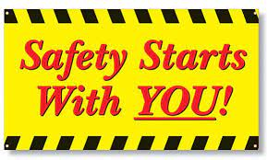







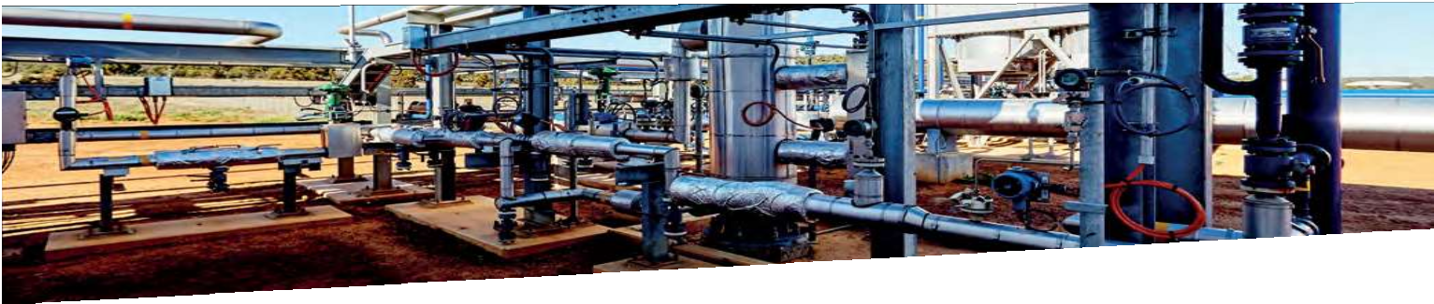

Collaboration with clients is our utmost priority for enabling successful delivery; developing a safe and effective culture of continuous improvement, responsiveness and high performance.
Over time, we have developed strong relationships in the communities in which we work, as a local employer we support many community organizations and events. A regionalized Corporate Social Responsibility program ensures support is aligned with local community priorities in our major project locations.



Customers Are Always Our Top Priority.

info@ecdarl.com
www.ecdarl.com
+ (234) 708 872 4745

